3D Printed 5P71 (P95) / 5N11 (N95) Respirator
  - Overview and Instructions
The respirator consists of a mask, a filter housing, a 3.75” strip of weather stripping, and elastic bands with adjusters. A nose clamp is included that can be glued on if difficulty is encountered getting a seal.
The parts are shown in the diagram below. Note: weather stripping and elastic are not pictured.
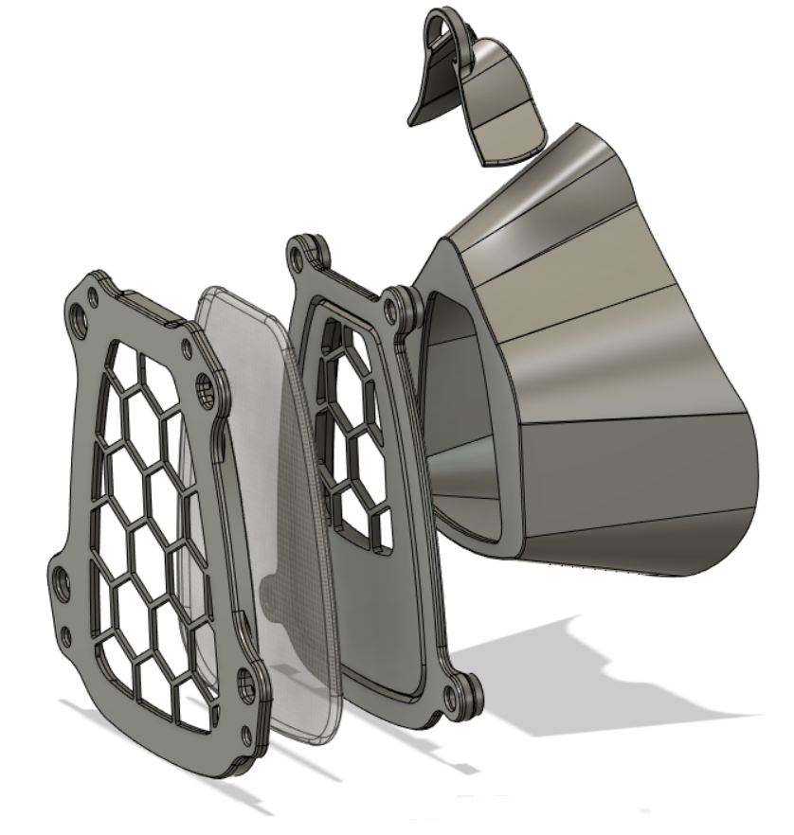
MATERIALS: The mask is polyurethane (TPU) and the housing and nose clip are polylactic acid (PLA).
CLINICAL USE STATUS: PROTOTYPE / UNDER REVIEW FOR CLINICAL USE
- Submitted to NIH for testing and clinical review. https://3dprint.nih.gov/discover/3dpx-013645
- Note that the FDA is currently working with the NIH to evaluate clinical use cases for PPE
  - For more information, see https://3dprint.nih.gov/collections/covid-19-response

FITTING:
- Check that the weather stripping is properly adhered to the inside of the nose area of the mask
- Familiarize yourself with the elastic adjuster
- Flip the top elastic over the front of the respirator (out of the way)
- Pull the bottom strap behind your head and fit the respirator onto your face
- Pull the top piece of elastic onto your head, above the ears
- Adjust the elastic until an adequate pressure is applied
  - Remove the respirator to adjust the elastic if required
- Breathe in an out normally and see how the seal works with each exhale (also try talking)
- Exhale sharply and see if any air escapes by your nose; tighten the elastic if required
- If trouble with the fit around the nose is persistent, install the nose clamp per figure 1
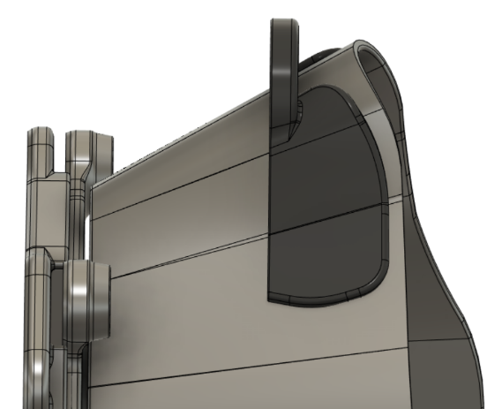
Figure 1, Right: Nose clamp install (OPTIONAL)
- The front of the nose clamp should be parallel to the front of the respirator
- The back of the nose clamp should be about 2mm from the back (face side) of the mask
- Use superglue or superglue gel (cyanoacrylate glue)
- Align the crease in the nose clamp with the crease in the mask and hold the surfaces together for 1-2 min
- Allow to dry until no fumes can be detected (2+ hrs.)

CLEANING AND SANITIZING:
- With a sanitizing wipe, clean and sanitize the entire mask, and all accessible portions of the filter housing after each use and allow to air dry
  - Take care around the weather stripping
- Double check that the weather stripping is still adhered well enough to survive the next shift
DISINFECTING:
- Clean and sanitize the respirator with a sanitizing wipe before disinfecting
- Remove and discard the weather stripping; wipe the area with the sanitizing wipe
- Remove the front cover of the filter housing with a 2.5mm Allen wrench
- Remove the filter and set aside, text down, on a disinfected surface
- Spray the entire respirator liberally with 70% isopropyl alcohol and let dry overnight
  - Soaking is acceptable, but additional drying time may be necessary
- After drying, attach a new 3.75” long piece of 1/4” foam rubber weather stripping
- Install a new filter (text towards face mask), or insert the old filter if no new filters are available
FILTERS:
- The respirator fits 3M 5P71 filters (P95 rating) and 3M 5N11 filters (N95 rating)
  - These filters are common add-ons for full face respirator units, adding particle protection to a cartridge designed for organic vapors, acid gas, etc.
  - When disposable N95 respirators are not available, it still may be possible to find a source for the 5P71 and 5N11 filters. Amazon.com still had them as of April 2020.

